**WILL THEY PAY?**

**PREDICTING IF USERS WILL PAY FOR APPS USING WORLDWIDE MOBILE APP USER BEHAVIOR DATA**

**Jaysmit Jadhav**

[jaysmit@mail.com](mailto:jaysmit@mail.com)

**ABSTRACT**

This project proposes, evaluates and interprets machine learning models to predict if mobile phone users will pay for apps. We used the Worldwide Mobile App User Behavior dataset which is obtained by surveying 10208 people from more than 15 countries on their mobile app usage behavior. We first explored the data to understand the user demographics, personalities and their usage patterns. We then predicted the user payment behavior using different classification and ensemble algorithms. Random Forest and Extra Trees classifier were the most successful models achieving validation and testing accuracies of 70%. We further use model interpretability libraries SHAP, Eli5 and Permutation Probability to understand the predictions and the feature values responsible.

**I INTRODUCTION**

Since the launch of modern smartphone in 2007, the mobile phone industry has proliferated. Over 3 billion people spend substantial amounts of their day using apps on their smartphones with global internet penetration standing at 57%. Today, there are almost 2.46 million apps available for download in Google Playstore, 1.96 million in Apple App Store, 700,000 in Windows Store, and 479,000 in Amazon Appstore. Although many have seen mammoth success, most of them turn out to be unsuccessful. Of the paid apps, about 90 percent are downloaded less than 500 times per day — and earn less than $1,250 a day. Moreover, 80% of them received less than 100 downloads. While competition in the app market is high, failure isn’t always a result of getting lost in the noise. In most cases, there are other contributing factors. Poorly researched market and audience would most likely top that list.

This work is relevant not only relevant to B2C paid apps but all apps. The analysis of the results will help facilitate new challenges to market-driven software engineering related to packaging requirements, feature space, quality expectations, app store dependency, price sensitivity and ecosystem effect.

**II DATASET**

We used Lim, Soo Ling, 2014, "Worldwide Mobile App User Behavior Dataset", https://doi.org/10.7910/DVN/27459, Harvard Dataverse, V1 dataset for our project. The dataset contains the results of a survey of 10208 people from more than 15 countries on their mobile app usage behavior. The countries include USA, China, Japan, Germany, France, Brazil, UK, Italy, Russia, India, Canada, Spain, Australia, Mexico, and South Korea. The respondents were asked about: (1) their mobile app user behavior in terms of mobile app usage, including the app stores they use, what triggers them to look for apps, why they download apps, why they abandon apps, and the types of apps they download. (2) their demographics including gender, age, marital status, nationality, country of residence, first language, ethnicity, education level, occupation, and household income (3) their personality using the Big-Five personality traits.

The dataset also contains metadata such as os, browser, screen resolution, flash version, etc. from the machine the users used to take the survey.

**III DATA WRANGLING**

The dataset comprises of 10208 observations and 161 variables. 71.5% of the data contains missing values with some variables having almost 98% values missing. The 161 variables were distributed as 45 numeric, 13 categorical, 101 boolean and 2 date. Some variables have very high cardinality. Model variable has 4421 distinct values.

The survey questionnaire was used as a guide to change the numeric columns to correct categorical columns. The high cardinality columns were mostly as a result of string values inputted by the users. String manipulation techniques were used to convert strings to categories. The missing values from boolean columns were filled with zeros after studying the dataset.

The target variable ‘do not pay for apps’ was one of the 10 multiple choice options for the survey question – Why do you spend money on an app? In order to minimize bias, the other 9 options were dropped from the data. The metadata was excluded for modeling in order to restrict the predictions strictly based on user behavior. The cleaned data was saved as a pickle file to retain the changed datatypes.

**IV EXPLORATORY DATA ANALYSIS**

In this section, we investigated and explored the data to understand the user demographics, personalities, user adoption of the app store, app needs and the rationale for selecting or abandoning an app. We also focus on the differences of these findings between the payment behaviors.

1. **Distribution of users**

The demographics of the surveyed people are explored in this subsection.

**a.1. Gender Ratio**

The data has a balanced gender ratio of 48.63% males and 51.73% females. The number of men who paid for apps is almost same as men who didn't. But there is a larger gap in this ratio for women.

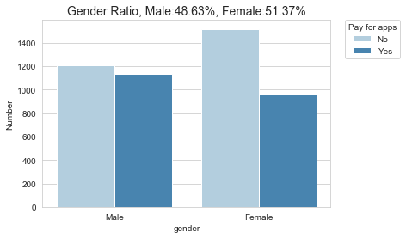

Figure 1 Gender Ratio and payment behavior

**a.2. Nationality**

The number of users who pay for apps is more than twice the number of users who don't in China. Mexico is the only other country where more number of users pay for apps than don't.

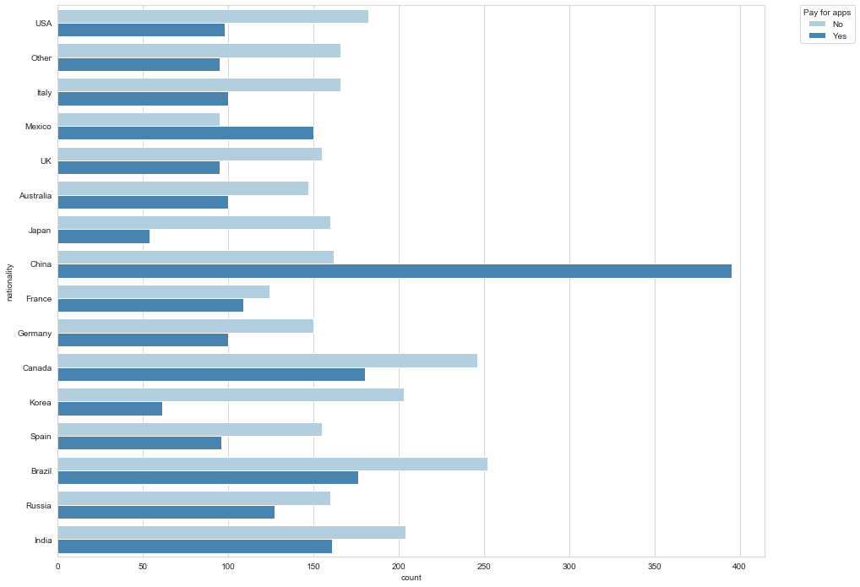

Figure 2 Nationality and Payment Behavior

**a.3. Age**

Age has a right-skewed distribution with peak at 20.

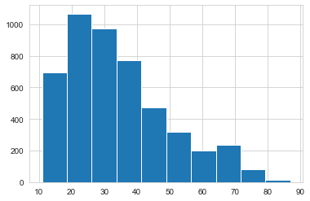

Figure 3 Age

1. **Personality Traits**

Personality may influence the types of apps one likes and if they are willing to pay for an app. In this section, we explored the different personality traits on a scale of 1 to 7, value 1 is where they 'Strongly disagree' with a characteristic and 7 as 'Strongly agree'.

We see influence of social desirability bias for all the personality traits' distributions. For all traits, the most frequent rating was in between 2-6 which suggests that people shy away from rating themselves with strong characteristics. Traits with positive connotation such as extraverted, enthusiastic, dependable, self-disciplined, open to new experiences, sympathetic, warm, calm, emotionally stable showed left-skewed distribution i.e. majority of people agree that these traits apply to them. Traits with negative connotation such as critical, quarrelsome, anxious, easily upset, disorganized, careless, conventional, uncreative showed right-skewed distribution i.e. majority of people disagree that these traits apply to them. Reserved, quiet was the only trait which showed almost a normal distribution.

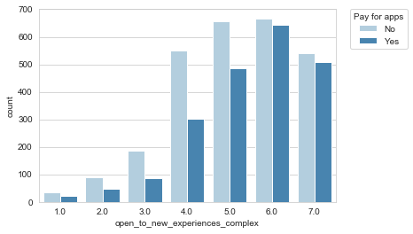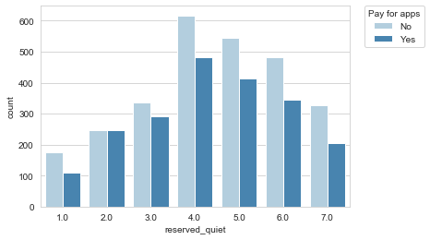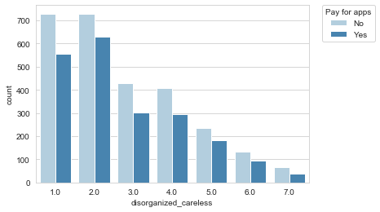

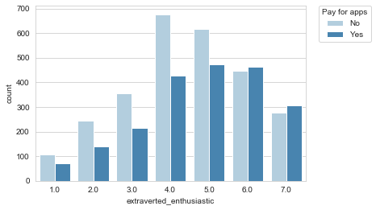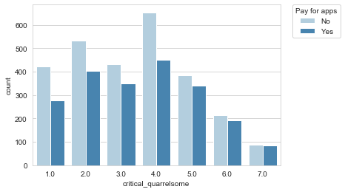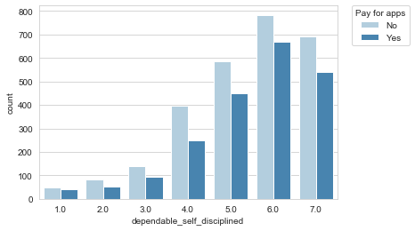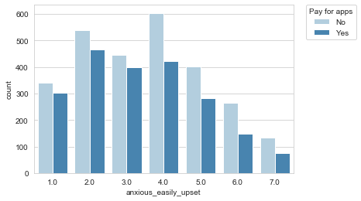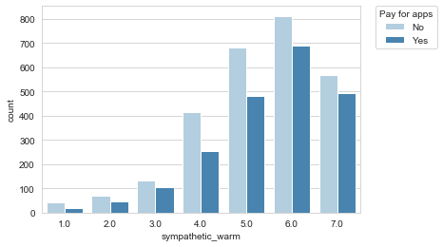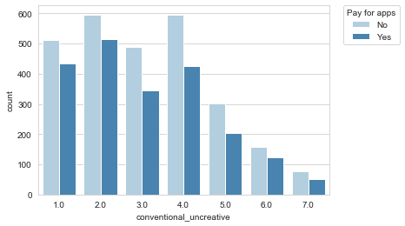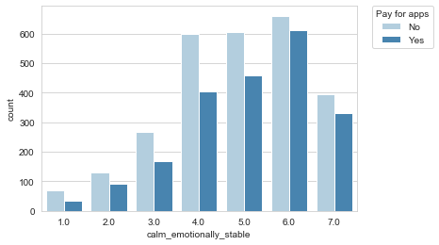

Figure 4 Personality Traits showing influence of social desirability bias. Users who strongly agree that they are extroverted and enthusiastic were the only group where there were more payers than non-payers.

1. **App Store Adoption**

It is important to understand how best to develop apps and app stores such that users can find apps. In this section we investigate user behavior relating to seeking apps, in terms of the platform used, frequency of use of that platform, frequency of downloads and methods used to search for apps.

**c.1. User distribution across mobile app platforms**

Google (Android) Play Store was the most used app store followed by Apple (iOS) App Store. This is consistent with the current market share of smartphone operating systems.

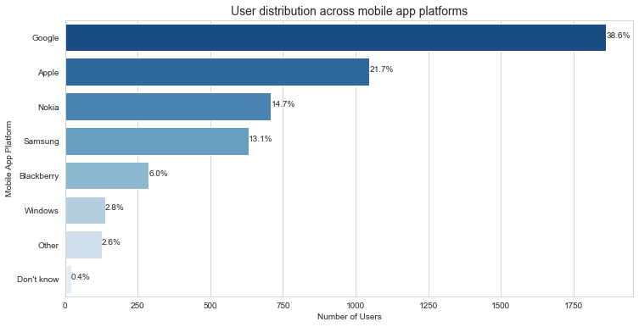

Figure 5 User distribution across mobile app platforms

**c.2. Frequency of visiting app store**

More than one a week was the most common frequency that users visited their app store. This was followed by less than once a month and once a week. The least common frequency of visiting the app store was several times a day. Approximately, 9% of users reported not visiting the app stores to look for apps.

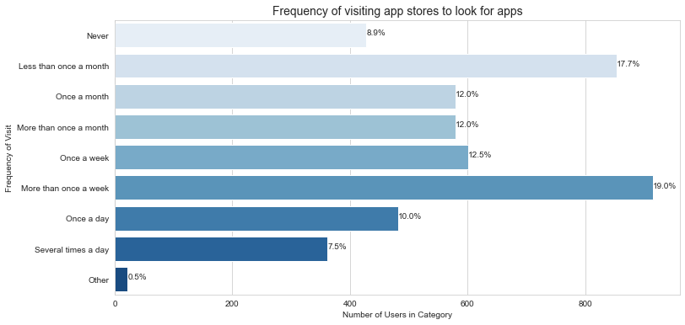

Figure 6 Frequency of visiting app stores to look for apps

**c.3. Average Apps downloaded per month**

The highest proportion of users downloaded 2–5 apps per month (40%). This was followed by 0–1 apps (35%), 6–10 apps (14%), 11–20 apps (7%), and 21–30 apps (2%). Only 2% of users downloaded more than 30 apps per month.

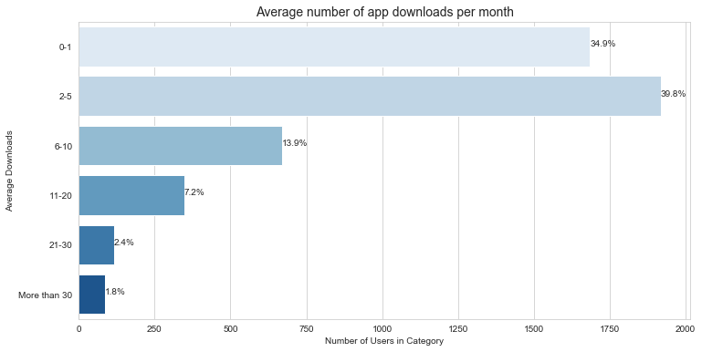

Figure 7 Average number of app downloads per month

**c.4. Methods used to find apps**

The majority of people found apps by keyword search in the app store (19%). This was followed by browsing randomly (17%), using search engines such as Google (16%), looking at top downloads chart (13%), and comparing several apps(11%). The least number of users reported downloading the first app they found(3%), suggesting that users tend to spend some time choosing apps, even if the apps were free.

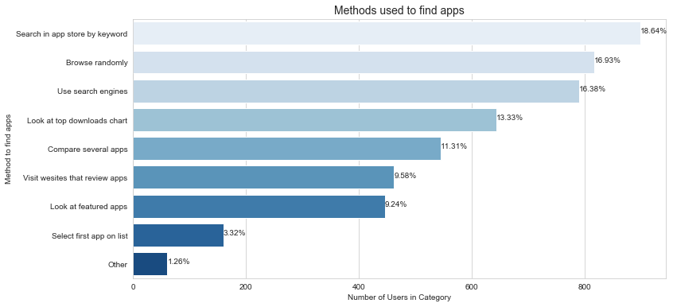

Figure 8 Methods used to find apps

1. **User Needs**

In addition to the mechanics of finding apps, there are the fundamental needs of the users. In this section, we aim to understand what might prompt a user to consider looking for an app in the first place, why they download apps, and which types of apps they prefer.

**d.1. Triggers**

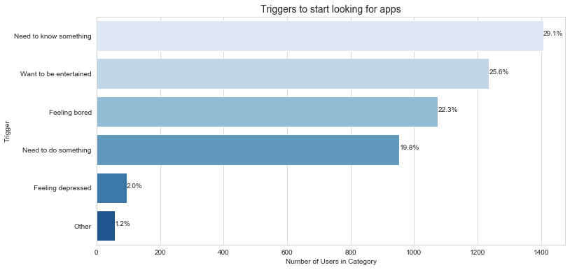

Figure 9 Triggers to start looking for apps

The most popular situation that triggered users to look for apps was when they needed to know something (29%), followed by when they wanted to be entertained (26%), and when they were feeling bored (22%). The least popular reason to look for apps was when users were depressed (2%). However, the respondents’ willingness to specify this option might have been influenced by social desirability bias.

**d.2. Reasons for downloading apps**

The most popular reason for users to download an app was to be entertained (20%), followed by to carry out a task (19%). The third most popular reason for users to download an app was because the app was recommended by friends or family (11%). This shows the importance of viral marketing and social networks on app downloads. Curiosity was also an important reason (10%), which meant that novel or quirky apps have the potential to attract downloads in the app store.

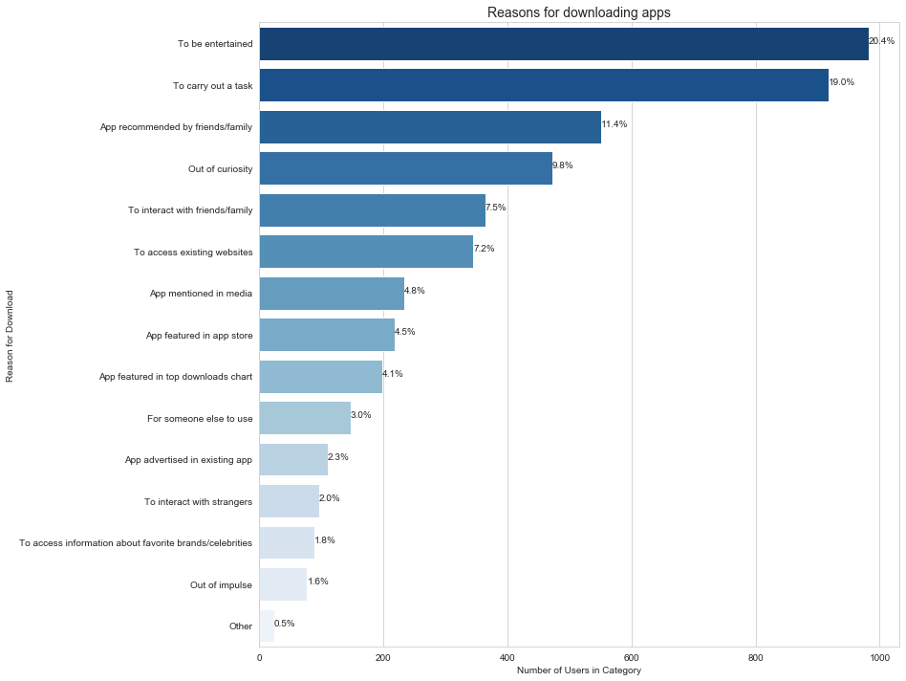

Figure 10 Reasons for downloading apps

**d.3. Types of apps**

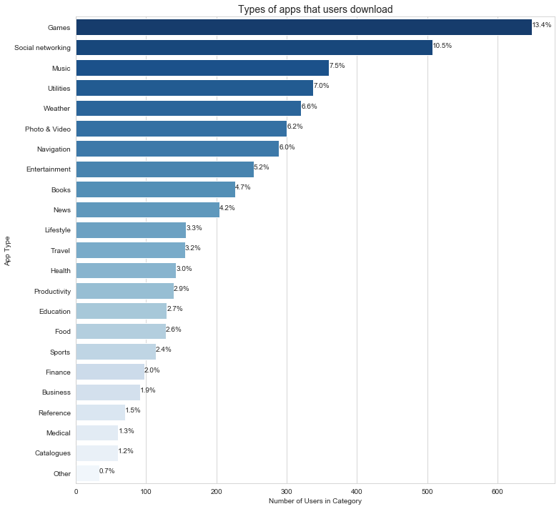

Figure 11 Types of apps that users download

The most popular app category was games (13%) followed by social networking (11%) and music apps (8%), which is consistent with the fact that the most common reason to download apps was to be entertained. Utility apps, weather apps and navigation apps were very popular too, indicating that apps play an important role in supporting very specific tasks and providing specific information.

1. **Influencing features for selection or abandonment of apps**

Apps must be advertised through app stores, potentially making non-functional and packaging requirements as important as functional requirements. In this section, we investigate the importance of app features versus descriptions, ratings, price, and perceived quality.

**e.1. Factors that influence users' choices of apps**

The most important factors that people consider when choosing apps were: price (17%), app features (14%), app description (13%), reviews by other users (12%), and star ratings (11%). The least important factor that influenced a user’s choice of apps was the developer (2%). This meant that developers would find it difficult to use the success of their previous apps to promote future apps.

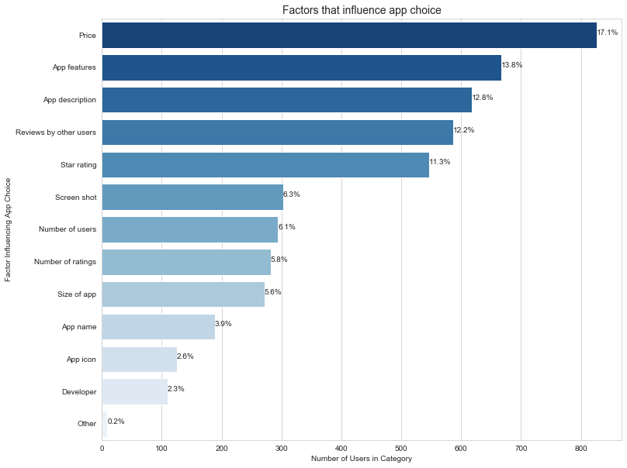

Figure 12 Factors that influence app choice

**e.2. Reasons for rating apps**

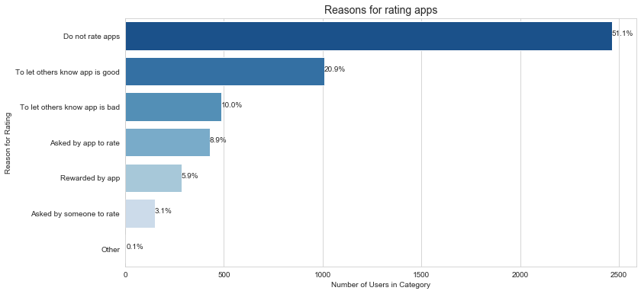

Figure 13 Reasons for rating apps

51% of users did not rate apps. The most popular reasons for rating apps was to let other users know that the app was good (21%), followed by to let other users know that the app was bad (10%). Interestingly, the app rewarding users to rate it (6%) was a less popular reason compared to the app simply reminding the users to rate it (9%).

**e.3. Reasons for paying for apps**

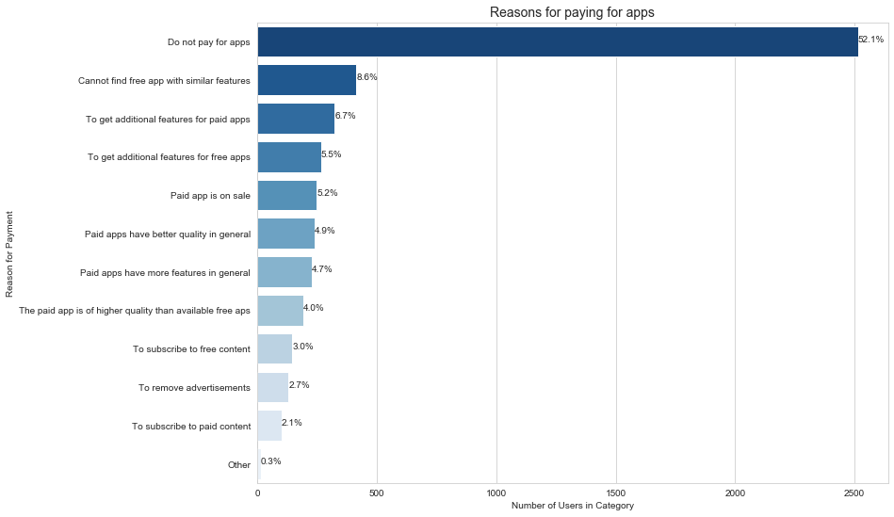

Figure 14 Reasons for paying for apps

Most app users did not pay for apps (52%). The most popular reasons to pay for apps were that users could not find free apps with similar features (9%). This was followed by the need to get additional features for paid apps (7%) and for free apps (6%), and that the apps were on sale (5%). Not many people paid to remove advertisements (3%). The least common reason people paid for apps was to subscribe for paid content (2%). This might be that when the content had to be paid for, users expected the app to be free.

**e.4. Reasons for abandoning apps**

The most common reason for app users to abandon an app was because they did not need the app anymore (14%). This was followed by finding better alternatives (11%) and getting bored of the app (10%). This finding suggested that many apps served temporary functions, unlike desktop software. Non-functional requirements such as performance, reliability and usability, were important for app users. Reasons such as the app crashed, the app did not have the required features, the app was too slow, the app was difficult to use, the app did not work, were, on average, adequate reasons for more than 37% of users for abandoning an app. This result showed that the quality of an app was crucial to encourage continued usage. Only 4% of users stopped using an app because it invaded their privacy. However, this might be due to app users being largely unaware of their privacy being invaded and the implications.

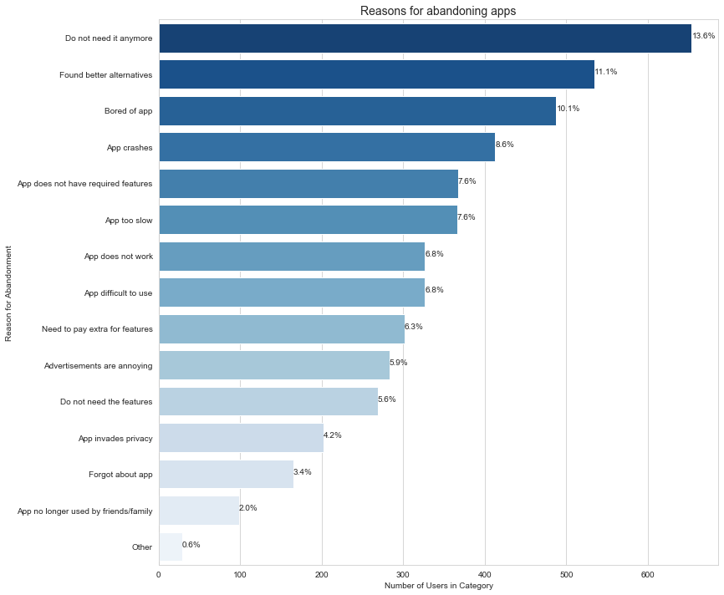

Figure 15 Reasons for abandoning apps